SARASOTA
SHARKS
GWRRA FL2-B2

Chapter FL2-B2 NEWSLETTER
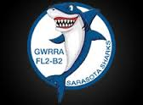
January 2019

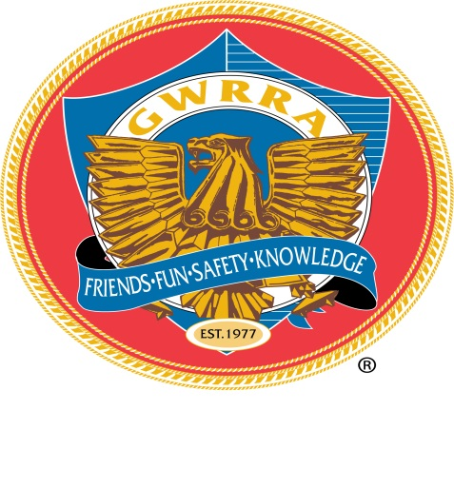
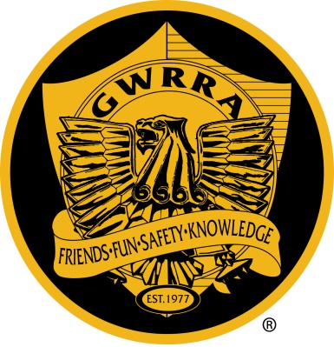
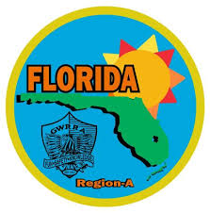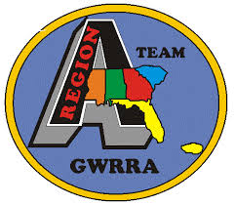

UPCOMING MONTHLY GATHERINGS
3rd Thursday
Perkins RestaurantSAFETY FIRST
5921 Fruitville Road Sarasota, FL 34232 FUN ALWAYS
Starts at Eat @ 6:00 Meet @ 7:00 PM Monthly

NATIONAL & STATE LEADERSHIP TEAM

NATIONAL DIRECTOR: Ray & Sandi Garris
DEPUTY DIRECTOR EAST: Bob & Nancy Shrader
REGION “A” DIRECTOR: Jim & Sue Jackson
REG. A ASST DIRECTOR: Ed Porter
FLORIDA DISTRICT DIRECTOR: Bill & Cheryl Smith
FL ASST. DIRECTOR: Harry & Lynn Anderson

Chapter leadership team
Directors:Bill & Barb Baner
Asst. Director: Dave Gladysz
Treasurer:Pam Gladysz
Membership Enhancement Coordinator:Barb Baner
Ride Coordinator:Bo Nepip
Web Master: William Anderson
Goodie Sales: Dave Gladysz
Individual of the Year:Matt Collis
Newsletter Editor: Need Volunteer Email:
Historian:TBA
Pam Gladysz – January 17
Barb Gonterman – January 22
Mereta Drakey – January 27
Dave Gladysz – January 28
Mereta & Tony Drakey
From the Lead Sharks
Bill & Barb Baner

Welcome to 2019. I know this year will be full of FUN and many new Changes. One change we will be making is “ MORE CHAPTER RIDES “!!!!! There are plans to visit more interesting Places, Restaurants, Ice Cream Rides and of course other Chapter Events. Two big Chapter events coming up are the FL2-L “ Fireball Cops & Robbers Rally” located in Auburndale on February 9th, and the famous FL2-G “ Annual Chapter Chilli Cook-Off “ in Fort Myers on February 16th. One of our goals for 2019 is to keep the Chapter Calendar up to date with where we are going on our Chapter Rides. If you have ANY SUGGESTIONS on where you would like to go or eat PLEASE let us know. Remember, you don’t have to lead the Ride ( but you are ALWAYS welcome to do so ).
We have a new communication tool to let everyone know what is happening in our Chapter. The Florida District is rolling out a new program called “ Group Works “. I will review with everyone how to use it at our next Chapter Meeting.
Pam, Dave Gladyzs and myself attended the Florida District Conference last weekend. There was a lot of new information shared with everyone and safety seminars that was attended by all.
Our upcoming Florida District Rally is coming up March 21st to March 23rd. There will be plenty of Vendors and Activities for everyone. Please mark this date on your home calendar and let’s have a good turn out to have some FUN TOGETHER. I will pass around the Flyers at our next Chapter Meeting.

See you at our next Ride or Chapter Meeting……

Ride Safe,
Bill & Barb Baner
Chapter FL2-B2 Senior Directors

From our Florida District Educator

My, my, my, this winter has brought back some childhood memories. Has it for you? For me it brought back those memories when I would go to the county fair and ride that big ole roller coaster, up, down, around and around. Wow, such fun and so fast. How does this winter remind me of that you ask? Well this weather has been like a roller coaster, the temperature has been up one day and down the next day. Up the next day and down the next day. Wow, what a winter, It can’t make up its mind.

This morning I get up and it’s 35 degrees in my carport. My bike says “OH NO YOU DON’T!” So it’s back to a nice warm cuddly, toasty, warm, (did I say warm already?), bed until it warms up a bit!

OK, OK, so you know where I’m going with this. Most of you northerners don’t really mind a day or two of this “cooler” weather but those of us that have been her for over 60 years have gotten a bit used to the warmer temps. Therefore we must remember to dress appropriately after we brave these frigid temps. You know, for those of us that do live here in God’s country 365 and don’t invest in heated riding gear, we need to remember to layer our clothing for this Florida sun. Cooler in the morning needs more layers, as the day progresses and warms up we can shed a few garments. As the day wears on the sun nears the horizon the temps drops we can put those garments back on for more warmth and head for that nice warm, cuddly, toasty, warm, (here we go again), well, you get my drift.

Not only do we ATGATT, (All The Gear All The Time), but, we need to use common sense when we face the elements even here in sunny Florida. So please

Ride Safe, Ride Aware,

Rick & Pam Northrop
Senior District Educators

CHAPTER 2019 CHRISTMAS PARTY

